Proxy Servers

* It’s a dedicated computer / software system virtally located b/w a client and actual server
* It’s a sentinel b/w internal network and the open network
* It serves clients requests on behalf of actual servers 🡪 preventing actual servers from exposing themselves to outside world
* Provides additional layer of defense to thenetwork & protect against certain OS and web server specific attacks
* Security professionals should deploy a proxy server to intercept malicious, offensive web content, computer viruses, etc hidden in client reqests

User -🡪 PROXY SERVER -🡪 Server

# Benefits

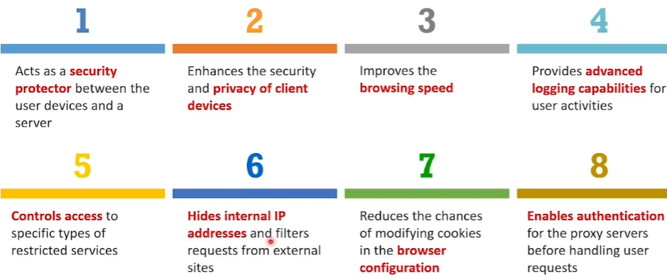

# Functions

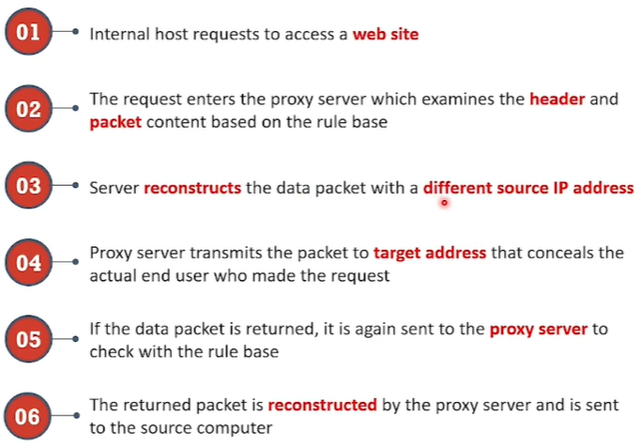

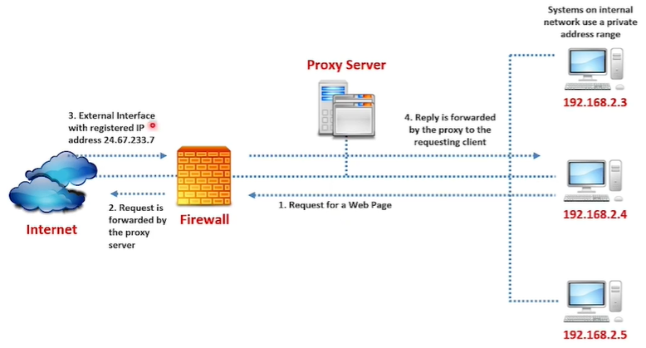

# Proxy server vs Packet filter

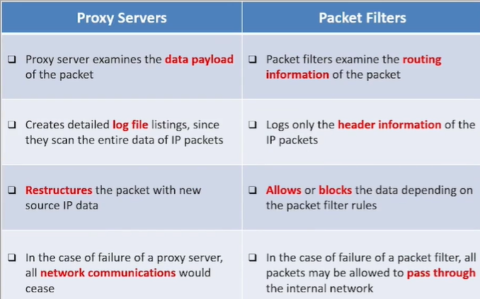

# Types of proxy server

1. Transparent proxy
2. Non transparent proxy
3. SOCKS Proxy – **IEFT standard**
4. Anonymous Proxy
5. Reverse Proxy

## Transparent Proxy:

* Client system connects to a server without its knowledge
* Completely visible to end user
* All web clients must be configured manually

## Non-transparency

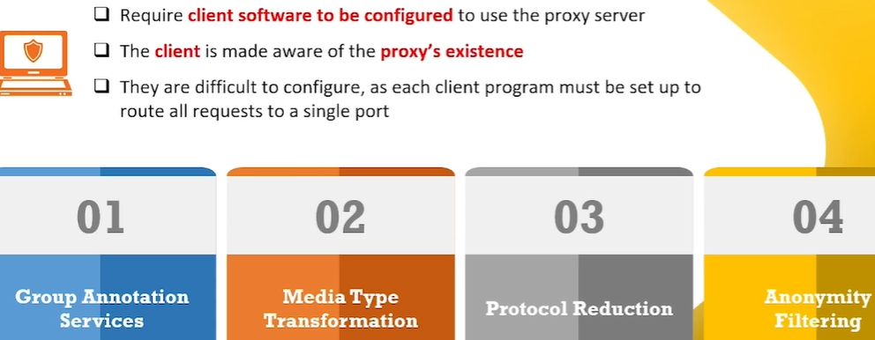

## SOCKS Proxy

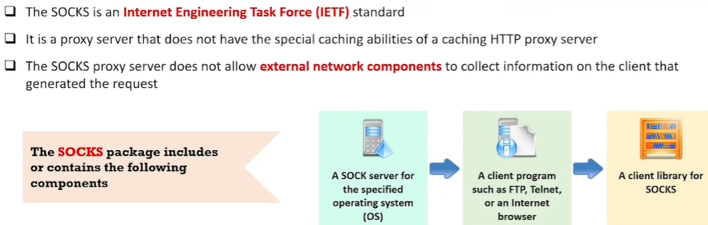

## Anonymous Proxy

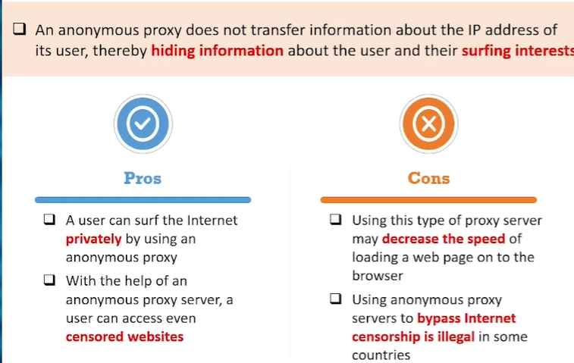

## Reverse Proxy

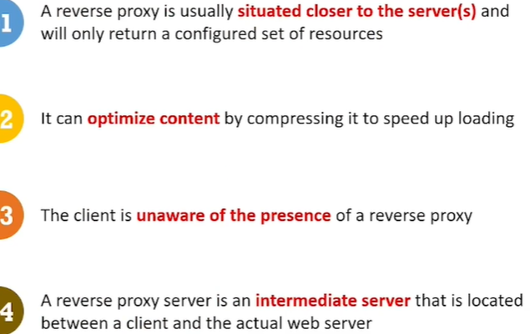

## Configuring proxy server in windows 10

### Method-1

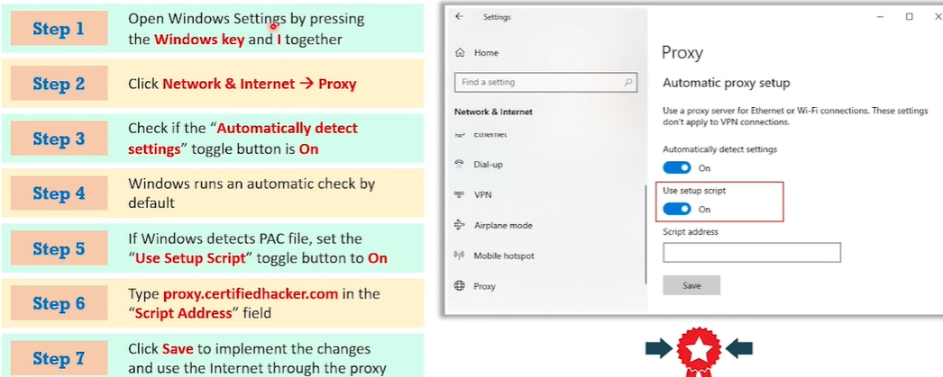

### Method-2

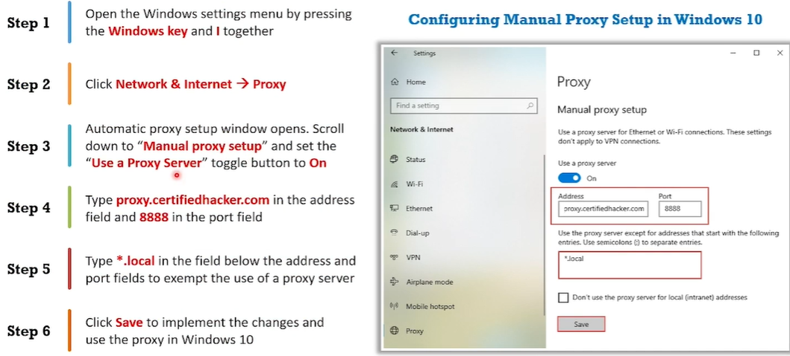

## Proxy server in Google chrome

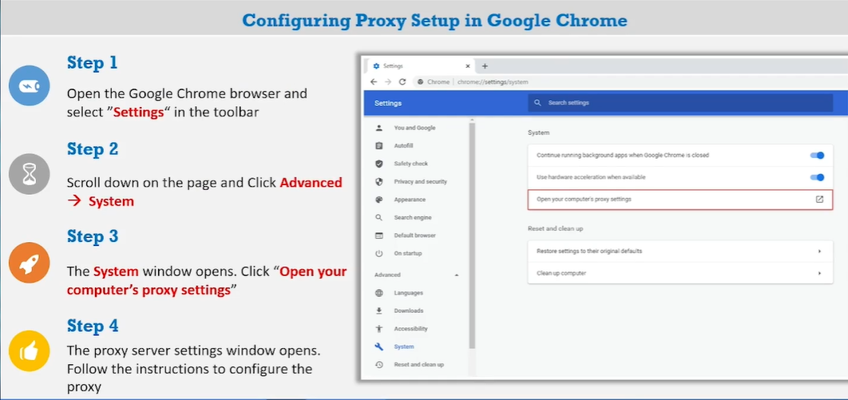

## Proxy server in Microsoft edge

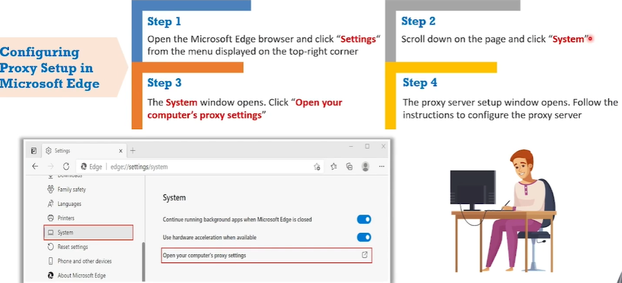

# Limitations

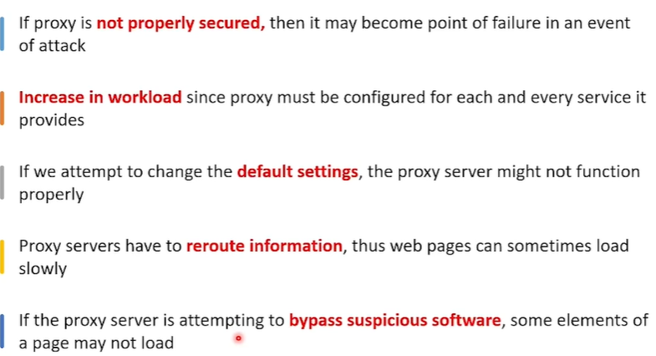

# Example of proxy server: Squid server

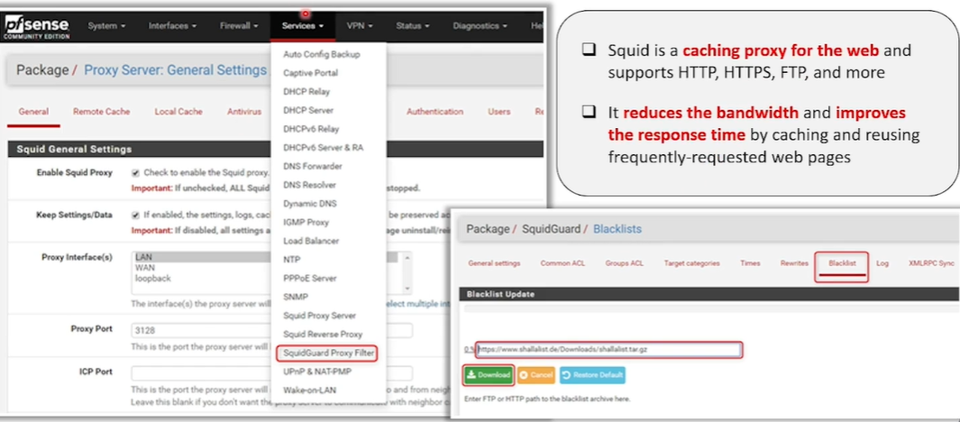

# List of proxy tools

